Week 1
Session 4 - 1
Code :
class Solution {
public int[] runningSum(int[] nums) {

for (int i = 1; i < nums.length; i++) {
nums[i] = nums[i] + nums[i - 1];
}

return nums;
}
}

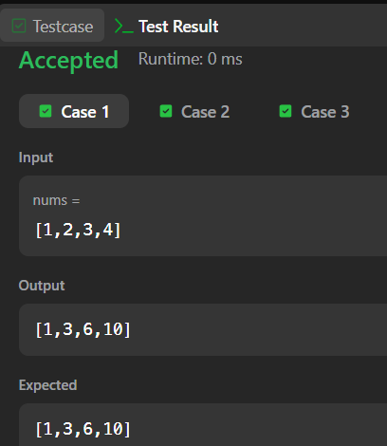

Session 4 - 2
Code :
class Solution {
public int maximumWealth(int[][] accounts) {

int maxWealth = 0;

for (int i = 0; i < accounts.length; i++) {

int wealth = 0;

for (int j = 0; j < accounts[i].length; j++) {
wealth += accounts[i][j];
}

maxWealth = Math.max(maxWealth, wealth);
}

return maxWealth;
}
}

